**DAILY ONLINE ACTIVITIES SUMMARY**

|  |  |  |  |  |  |  |  |  |
| --- | --- | --- | --- | --- | --- | --- | --- | --- |
| **Date:** | **20/06/2020** | | | | | **Name:** | **RITIKA R KULKARNI** | |
| **Sem& Sec** | **4​th​ SEM. & ‘B’ SEC.** | | | | | **USN:** | **4AL19CS403** | |
| **Online Test Summary** | | | | | | | | |
| **Subject** | | **DATA COMMUNICATION** | | | | | | |
| **Max. Marks** | | **30** | | **Score** | | | **20** | |
| **Certification Course Summary** | | | | | | | | |
| **Course** | **INTRODUCTION OF CLOUD** | | | | | | | |
| **Certificate Provider** | | | **Cognitive class** | | **Duration** | | | **5 Hrs.** |
| **Coding Challenges** | | | | | | | | |
| **Problem Statement:**   1. **Circular array rotation means rotating the elements in the array where one rotation operation moves the last element of the array to the first position and shifts all remaining elements to the right.** 2. **Program that compares counting words in files using an ArrayList and a Map.** 3. **Given two numbers ‘a’ and b’. Write a program to count number of bits needed to be flipped to convert ‘a’ to ‘b’.** | | | | | | | | |
| **Status: Executed.** | | | | | | | | |
| **Uploaded the report in Github** | | | | | **Yes** | | | |
| **If yes Repository name** | | | | | <https://github.com/ritikakulkarni> | | | |
| **Uploaded the report in slack** | | | | | **Yes** | | | |

**Online Test Summary:**

**18CS46 test was scheduled from 2:00 pm to 2:30 pm. The portion for the IA was 4th module there were 20 questions and the time assigned was 30 minutes the questions were mcq type.**

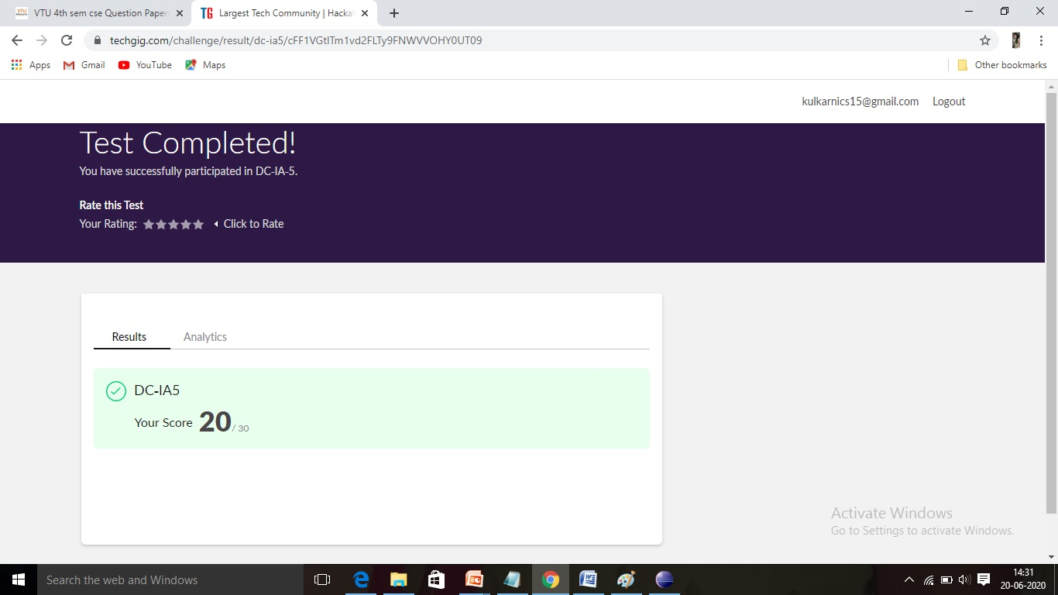

**Online Certification course Summary​: Today, I went through the Hybrid cloud blockchain and Analytics on the cloud and I got certificate.**

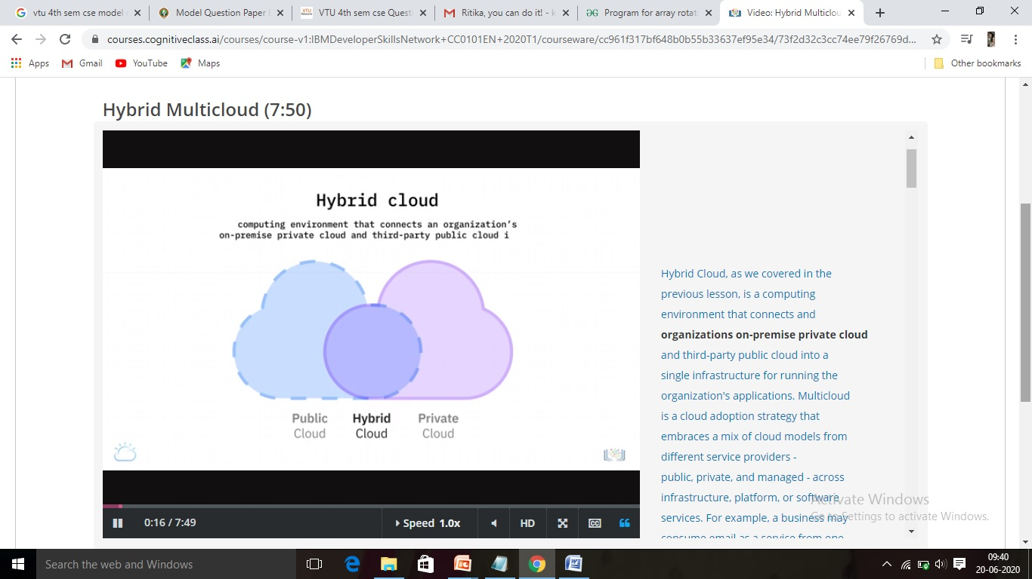

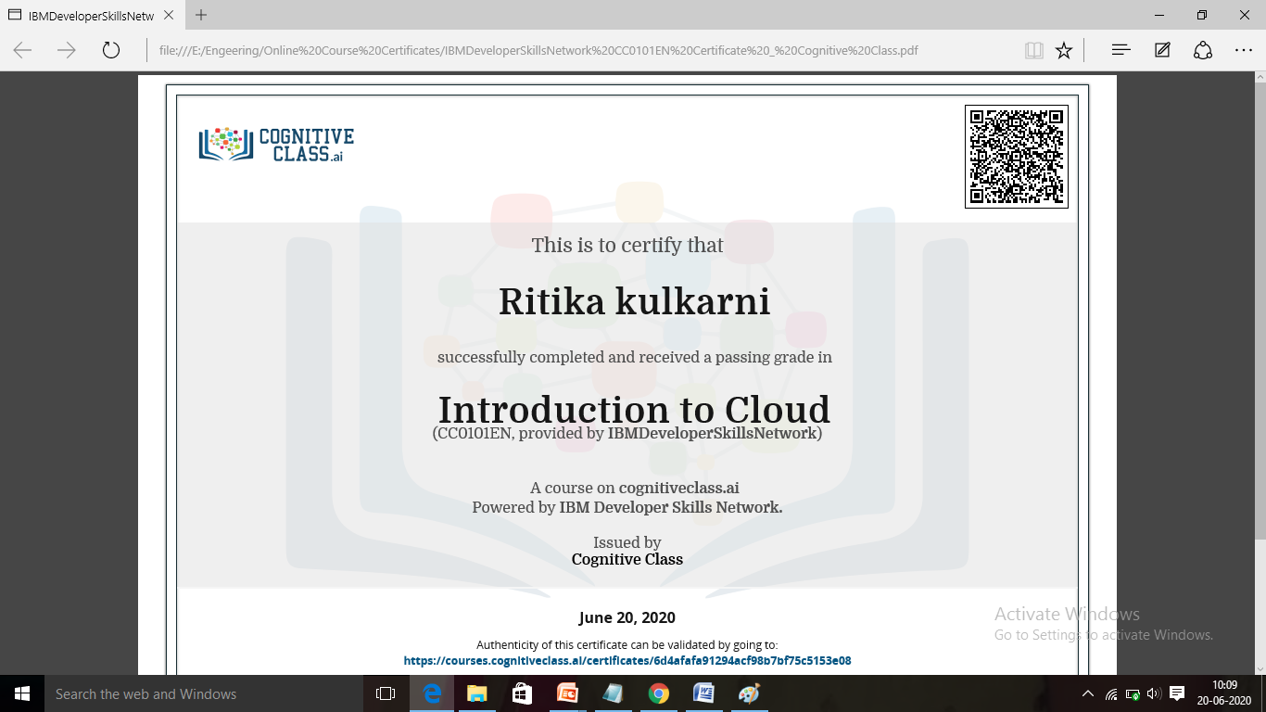

**Online Coding Summary​:Today I received three programs from Shilpa Mam and prof. Vasudev sir CSE Dept.. I have written two program and uploaded it to my Github repository. This is my repository snapshot. I have uploaded the frequency program.**

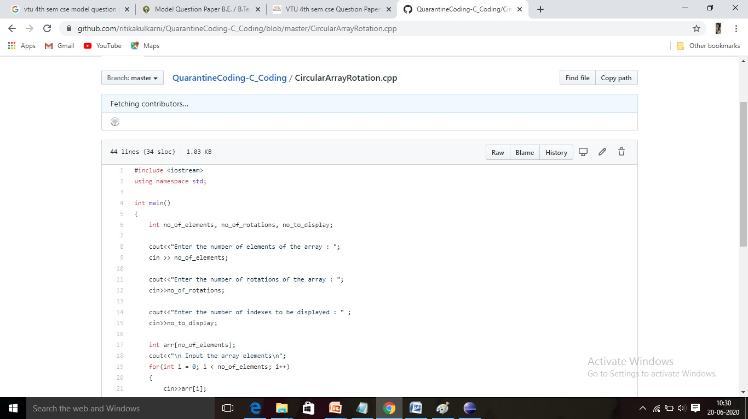

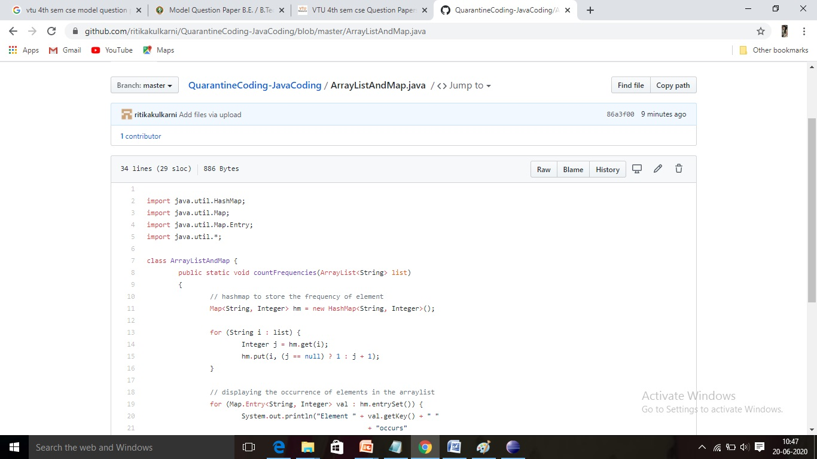

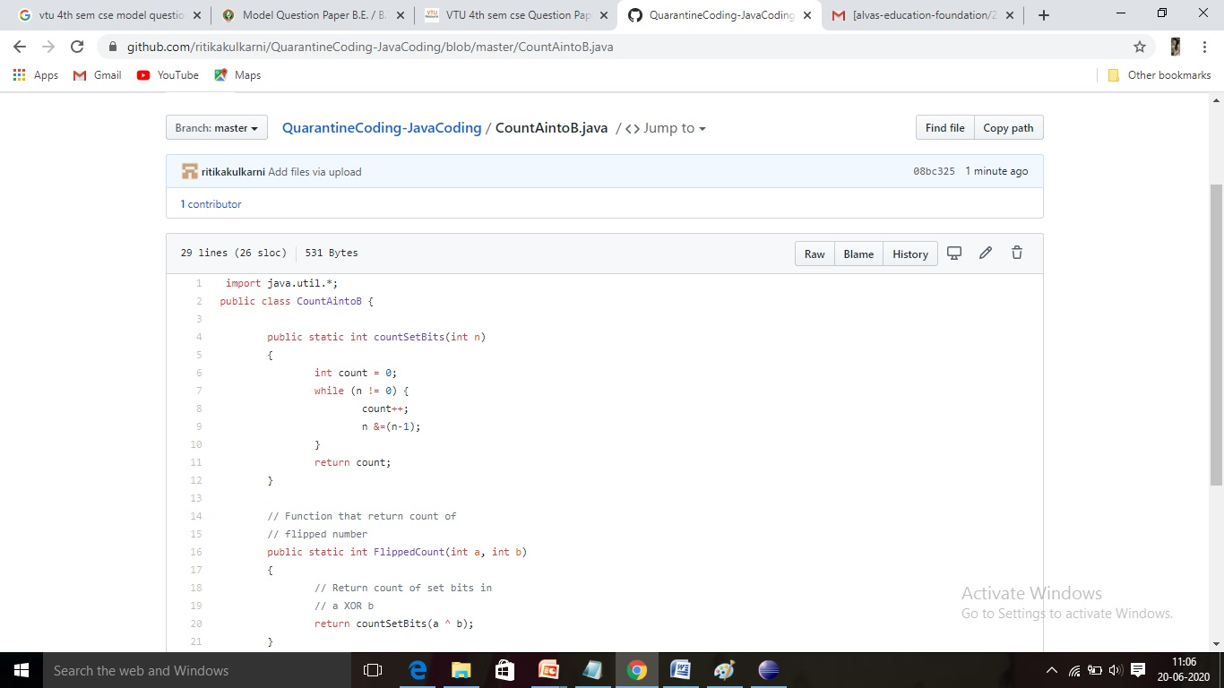**Thank you**